Introductory Financial Accounting
Assignment Step 3: Background information of company and industry
Clover Corporation:




Initial Thoughts
When I first saw my company, I was intrigued to discover what it was all about. I had never heard of Clover Corporation nor did I know the industry it was apart of. When I opened the link, I was happy to discover that it was apart of the health industry. I have a vast interest in health care and love knowing the ins and outs of health products. Little background story, I used to work at a pharmacy for 5 years so that’s where the interest stems from. Their website instantly caught my eye as it was extremely well put together and very appealing to the eye. It was easy to navigate around and had immense amounts of information on their products and their company history. They are evidently a very successful organisation who are growing every day. I cannot wait to delve more into their business and analyse the annual reports of a thriving business.
Clover Corporation Annual Reports
2017 Annual Report
2018 Annual Report
2019 Annual Report

Background Information
The company of focus throughout the rest of the assessment is Clover Corporations. Click HERE to find their website. Their website was effectively set out which allowed all relevant information to be found.
Clover Corporation is an Australian based business who specialise in the manufacturing of Omega-3 and Omega-6 products. Their journey began in the 1988 and was solely build around the vision of Hamish Drummond, who’s ultimate goal was to improve individual’s health with Omega-3 Fatty Acids. This goal and ambition transformed into a great Australian success story as they are currently thriving within their market today. Their turning point happened in 1999 when Clover became publicly listed on the Australian Securities Exchange. When this happened, they went from solely being a research, development, manufacturing, and marketing company to having a specific focus. That focus was on forming strategic relationships with technology, new product development and commercialisation.
Furthermore, in 2002, a joint venture was formed with Queensland-based Food Spectrum Group of companies where Clover owned 70% of Nu-Mega Ingredients Pty Limited. This venture ceased in 2007 when Clover acquired the remaining 30% of Nu-Mega making it a wholly owned business. Since then, the company has thrived with the introduction of new products and the delivery of bioactive nutritional ingredients. Today, Clover concentrate on maintaining their status as global leaders within the Omega-3 and Omega-6 market as well as the infant nutrition and medical foods market which all hold immense reputation.
The health care industry is continuously thriving and evolving meaning Clover Corporation is always thriving and evolving. As mentioned previously, they provide the health care industry with Omega 3 and Omega 6 products which have become increasingly popular due to the amount of research and benefits it provides. As can be seen in the Eufic article, they highlight the importance of these products and how this industry is currently thriving which is positive for Clover. There are heaps of articles and blogs surrounding this industry and how important the products are. The links to these articles/blogs are provided below. While there are a many articles on Omega 3 and Omega 6 products and the health care industry, I really struggle to find any on Clover itself. Considering it is a very successful business, I would have expected more publicity. I did find one blog on Clover titled ‘Will shareholders get lucky with Clover Corporation’. It highlights Clovers new endeavour in producing infant formula and explains their success. It also assesses whether or not shareholders will ‘get lucky’ with the new product. It also displays a snapshot of their balance sheet showing how an increase in inventory will double the company’s net profit. These articles and blogs are shown below.
Articles/Blogs
https://www.eufic.org/en/whats-in-food/article/the-importance-of-omega-3-and-omega-6-fatty-acids
https://www.healthline.com/nutrition/3-types-of-omega-3
https://oracleag.com.au/2020/06/23/will-shareholders-get-lucky-with-clover-corporation/
Financials
Profit and Loss
As I flicked through the financial report for Clover, I instantly felt a sense of worry as not a lot of it made sense. I have dealt with various financial reports within my workplace but none as vast and documented as this. The first aspect I noticed was the language and how different it was to what I have seen before. Firstly, I analysed the profit or loss and other comprehensive income statement where I initially noticed an increase in revenue by $13,721 (AUD) from 2018. It can also be seen that there was an $67 increase in other income as well. This to me indicated that Clover obviously had a more successful year revenue wise as their overall comprehensive profit for 2019 totalled at $10.093 which compared to 2018 was a $2,459 increase.
Balance Sheet
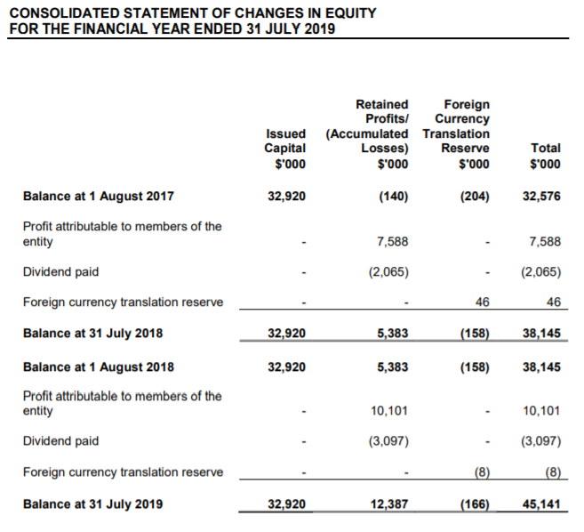
This might sound a little silly, but I was looking through the annual report and thinking to myself, where is the balance sheet? Only to realise five minutes later, that it was called a Consolidated Statement of Financial Position. First thing I noticed was the continued incline that the 2019 year had to offer. Current and Non-current assets both increased by significant amounts with the difference being $22,701. This usually means the business is growing and displays a good sign that the company is moving in the correct direction. There was also an increase in total liabilities from 2018 to 2019 showing a cash inflow and representing a source of funding. The total liabilities did not exceed the total assets which is positive for Clover as it shows they are able to sufficiently pay their debt obligations. The one aspect I found extremely interesting was that each separate account increased from 2018 to 2019 in all forms of assets and liabilities. I didn’t expect such an increase from all accounts, I would of thought that the accounts would differ and not all increase at once. The only account that did not increase was intangible assets, instead, the figure stayed the same which is to be expected.
Changes in Equity
The changes in equity part of the annual report was quite interesting to read. It highlights the total comprehensive income and summarises the activity in take equity accounts from 1st July 2018 to 30th June 2019. It was also the first time I had seen a 2017 figure in a 2019 report. The one thing I noticed was that the ‘dividend paid’ aspect of the changes in equity statement had not been stated in the profit and loss or balance sheet. I found that interesting considering it plays a roll balancing the trail balance.

Step 4 – Written Component (Reflection/Questions)
I found myself putting this step off time after time. I was honestly scared of it, the unknown. However, once I had done literally everything else, it was time to put some effort into this step. After carefully reading the instructions and listening to the video with Maria, I felt a sense of confidence come over my body as I finally understood what to do and did not want to put it off anymore. Don’t ask me why I wanted to put it off in the first place but somehow my brain immediately placed doubt on this step before even reading it. I enjoyed recording my own transactions and I found the process immensely beneficial. I did struggle to identify an appropriate time period of transactions, but I felt like a month was more than enough. When creating the chart of accounts, I did wonder about the amount of detail to go in when creating the chart of accounts which is further described in question b below. How much detail is too little detail? And how much detail is too much detail? Is there even such thing as too much detail? These are the questions that ran through my head when completing the chart of accounts. While, I found the process very beneficial, it also made me realise how much money I spend! No wonder why I feel like I’m never saving. Little amounts going out everywhere. So, it taught me a thing or two accounting wise and it also taught me a thing or two about my spending habits.

Questions
- I was very confused when reading through the step 4 outline. I had heard of a chart of account before, in fact, I work with them every day; however, I did find myself second guessing my knowledge. When I began to watch the video explaining the process, I immediately paused it and began to do it myself and see if I could overlook the self-doubt I had. It was definitely an eye-opener to see the my very own transactions laid out and classified like that. It doesn’t seem so scary when you are coding and assigning a chart of account to other people’s transactions, but when they are my own it’s a whole different ball game. With that being said, I did enjoy the process and it made me really think about how to classify my transactions. For example, with my purchases at Target or ILove (local dress shop), I was conflicted with what chart of account to assign it to. I was tossing up between drawings and purchases but decided to go with purchases as they are purchases of my own. I hope I am right.
- I sometimes struggle to comprehend the right amount of detail to go into when creating a chart of accounts. I work at an accountancy firm and every accountant is different. Some of them have one account for each transaction and some have the same chart of account just broken up into sub-accounts. For example, if a transaction is showing a client got a new tyre on a tractor, one accountant will put the repairs and maintenance account to it while others have 4 sub-accounts for the repairs and maintenance account meaning that transaction will go to repairs and maintenance – tyre dealers instead of just the general account as they are providing more detail. The other accounts will usually consist of the same wording but for different types of repairs and maintenance such as auto-electricians, electricians and so on. I hope that makes sense! Moral of that story was that I’m never quite certain of how much detail to delve into when constructing a chart of accounts. The chart of accounts I have put together for my transactions are relatively basic and straight forward. I broke down the general expenses account and showed that it was relating to food and fuel but other than that, I kept them simple.
- As mentioned previously, writing out my very own transactions in a chart of accounts was a very daunting process but so was putting that information into an income statement. I think I found it daunting because I am so used to looking at a companies or partnerships income statement where they obviously have more money and transactions than I have. I have never really thought of my own transactions being in that light, so it was immensely interesting to see. The aspect I found most interesting when analysing the income statement was the profit/loss for that period, it definitely caught my eye showing me the profit I had made which was quiet surprising considering I feel like I am always spending my money. I found the record keeping of my own transactions extremely helpful and really showed me where most of my money goes. I have also learnt a few things about the record keeping process especially surrounding the income statement. I had never seen a chart of accounts become an income statement, but it was fascinating to see how it can be transformed and linked into an income statement. I will definitely be able to take this new found knowledge and apply it to my everyday job at the accountancy firm.
- The concept of accrual accounting still confused me to no end but the thought of it did cross my mind when creating my chart of accounts. Would any of my transactions apply to the accrual basis of accounting? The difference between cash and accrual accounting is the timing it takes to record. For example, cash is only recognised and recorded as a revenue or expense when it changes hand. Whereas, accrual accounting records a revenue when its earned and an expense when its billed. With that being said, I concluded that none of my transactions could be applied to the accrual accounting process. It is in my understanding that these types of transactions are incurred but not yet recorded and I believe none of my transaction comply to that definition.

Step 5 – Trail Balance

