Steps 3-4
Restating financials is the most difficult topic I’ve had to comprehend so far in this unit. Due to having a heap of other assignments as well, I left this one until the last-minute thinking it was going to be as smooth sailing as entering them. I was wrong. I relied a lot of Maria and her videos to help me understand the process as I was new to the whole aspect. However, I still came across many hurdles which made a 3-hour job turn into a 24-hour job.
Changes in Equity
When watching Maria’s video on restating the changes in equity, I originally thought it was going to be pretty easy. Once again I was wrong. Although it was very straightforward, I had trouble understanding and comparing my company’s financials (Service Stream) to Wesfarmers which would have made everything very easy. Service Stream’s changes in equity was quite small compared to Wesfarmers so I got confused when it came to entering Operating Comprehensive Income and Financial Comprehensive Income as I only has a figure for operating and that was only for 2015. I came to the dilemma of whether I had to add everything else in the spreadsheet even though it was 0 and I worried that it would throw my totals out. However, after carefully checking my formulas and ensuring all my figures were right, it all turned out good meaning my restating spreadsheet for changes in equity was correct.
Balance Sheet
I found myself reading the chapters again and googling a lot of terms and accounts as I was unsure how to classify them. Once I was sure of the classifications, everything else was immensely straightforward especially with the help of Maria as I just followed her video step by step. All my figures were entered correctly the first time which allowed the totals to be right and this to be a quick and easy process.
Income Statement
I really struggled with my income statement. As I mentioned before my company isn’t as big as Wesfarmers which means I had less accounts but the accounts I did have were quite different to Maria’s, so I struggled to follow the video and classify them correctly. Everything was going well until I got to the ‘Tax Expense’ part, I don’t know whether I did it wrong when entering the first time, but my company’s income statement did not have any accounts relating to tax. To fix this problem, I went back to Service Stream’s annual report and found an income tax expense area where I inputted all the information into my restatement. Although we were meant to link our figures, I could not as I had no tax accounts in my previous income statement which threw me off a bit. However, once I had entered them and kept watching the video I was feeling more at ease. I followed the video step by step and after each step I would pause and do it myself and I watched parts of the video multiple times so I could have a clear understanding. But when it came adding OI and NFD my totals did not match my original income statement. I went through and checked all my figures and did sums to try and work out my mistake but then it occurred to me that I wasn’t going to match because I didn’t have those tax accounts in my income statement, but they are there in my restated income statement. Therefore, extra numbers have been added in which would of course throw my balance. Unfortunately I don’t have time to message anyone or receive help and I am very unsure what to do from here therefore my restated income statement is incorrect.

Discussion with others:
Thank goodness for my peers as I wouldn’t have gotten through this without them. Whether it be our fakebook page or face to face discussions with the people in my class, I find it all very helpful. Along with that, some of us on the Townsville campus have became quite good friends and have created a group chat for any questions or discussions that need to be had. I wouldn’t be able to succeed on my own so I’m very grateful for all the discussions and information that is around me at all times. Below you will see a few examples of the discussions I’ve been involved in during the course of this unit.
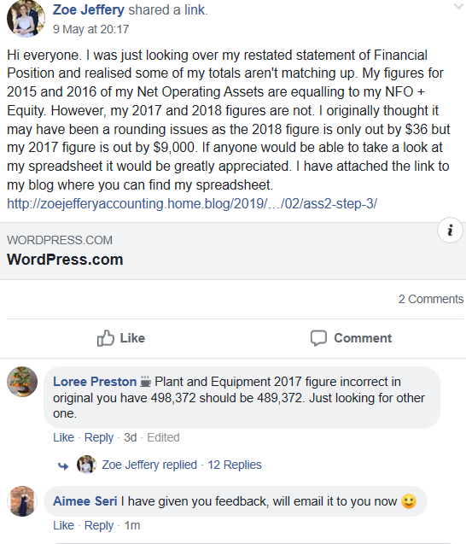
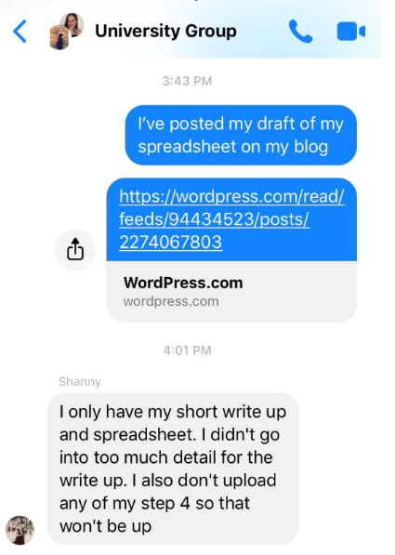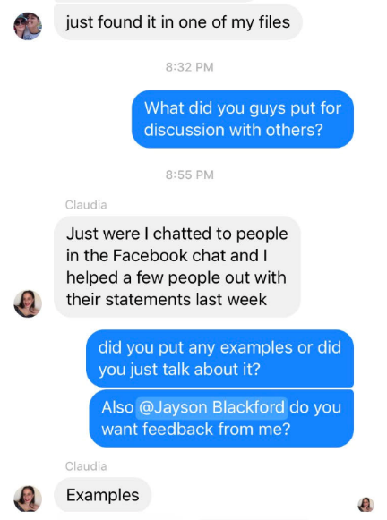

Feedback Given:
PEER FEEDBACK SHEET: ASS#2 Step 4
Feedback To: Claudia Turiano
Feedback From: Aimee Seri
 | My Comments
Step 3  Restated Statement of Changes in Equity  Balance Sheet  Income Statement  Commentary and discussion with others  (Note: You may wish to give some comments on their Excel spreadsheet) | Your spreadsheet was amazing. So neat, easy to follow and it all flowed. Great Work! It looked very professional, everything was formatted very efficiently, and nothing was out of place. I personally don’t think anything was wrong with it.  Once again, very professional and informational discussion. Good use of examples and tables to help the reader understand exactly what you are talking about. Everything was in order and really easy to follow. I loved reading about the challenges you came across as I feel I came across similar ones but overall you have done a great job. Good Work!
Step 4  Individual feedback with other students. | This section is not available
Overall ASS#2 Steps 3 & 4 | Overall, your steps 3 and 4 were great. Definitely one of the best I’ve seen. Very professional and a great amount of knowledge was used in the discussion as well as the spreadsheet. If there is any of other feedback or help you require, please do not hesitate to contact me. Great Work!

Feedback To: Zoe Jeffery
Feedback From: Aimee Seri
 | My Comments
Step 3  Restated Statement of Changes in Equity  Balance Sheet  Income Statement  Commentary and discussion with others  (Note: You may wish to give some comments on their Excel spreadsheet) | I was very impressed with the setup of your spreadsheet, it was very neat, tidy and professional. I checked for linking and formulas which all seemed to be correct, they were also evident as your restated totals matched the original ones. The only thing I think the spreadsheet could have used was bolded titles and totals, just to make it easier to densifier from the others. Other than that, you did an amazing job.  I loved reading through your discussion as well. It was short and sweet but very informational and it is easy to tell how thorough you are in your work. Great use to diagrams and examples of the topic you are discussing as it makes it easier for the reader to follow. Great Work!
Step 4  Individual feedback with other students. | This section is not available
Overall ASS#2 Steps 3 & 4 | Overall, you have done a great job. Very professional and it is evident that you are a very hard-working student and it shows through presentation. If you are after any other feedback, don’t hesitate to contact me. Once again, Great Work!

Feedback To: Jayson Blackford
Feedback From: Aimee Seri
 | My Comments
Step 3  Restated Statement of Changes in Equity  Balance Sheet  Income Statement  Commentary and discussion with others  (Note: You may wish to give some comments on their Excel spreadsheet) | I say this all the time, but your spreadsheet was very well presented. Everything was formatted perfectly. Only thing is, boarders around the total rows would make it easier to follow and allow it to be easily decipher what is a total and what is just a figure. I liked how you highlighted in different colours on your restated income statement as it shows that you were very thorough.  Your discussion was short and sweet, but it was great to learn about the challenges you faced as well as knowing what you found easy to complete. It was very informational and easy to read as you write very well. Great work!
Step 4  Individual feedback with other students. | This section is not available
Overall ASS#2 Steps 3 & 4 | Overall, this was one of my favourites. You were very thorough, and it is evident that you spent a lot of time perfecting it. You explained everything very clearly which allowed us readers to stay intrigued especially as I felt like I could relate to you and the challenges you faced. If you need any further feedback or help. Let me know. Good work Jayson!

Feedback Received:
Feedback To: Aimee Seri
Feedback From: Zoe Jeffery
 | My Comments
Step 3  Restated Statement of Changes in Equity  Balance Sheet  Income Statement  Commentary and discussion with others  (Note: You may wish to give some comments on their Excel spreadsheet) | On initial inspection of your spreadsheet I could not see any major issues. I did notice your income statement was not yet completed but other than that everything looked like you were on the right track. I did however notice you had a few formatting issues that should be addressed before handing in your final.  Your Statement of Changes in Equity needs a few teaks to make it appear more professional. I noticed that some of your figures in this statement had two decimal places while others did not have any. I suggest you address this by either having two decimal places for all figure or no decimal places. This will make your statement appear more professional. The other formatting issue I wanted to point out was the use of the $ sign. I suggest you remove this as at the top of your column you have indicated that all numbers are in $'000 (see below image).  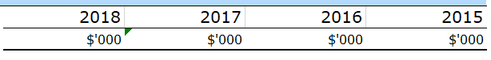  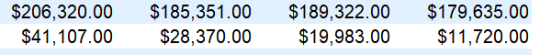  The $ sign is unnecessary and should be removed from your figures. The final formatting area that should be addressed in this statement is the use of the number 0. Maria suggested in her video that instead of indicating a 0 in an area where you do not have a figure, it should be left blank. This is done to indicate that the firm has not included the item for that period. I can see this has been done in all three of your financial statements. I do recommend if you change the 0’s to blank cells that you do this throughout. Whichever method you select I suggest you do it consistently in your spreadsheet – this makes it much easier to read and appears less jumbled.  Your balance sheet did not appear to have any major areas of concern. You have although indicated a highlighted section which you may want to remove to make your statement appear more professional. Your headings were all underlined and bolded making it easy to identify your separated sections. The only suggestion I have for this area is the use of italics. You could use italics to indicate totals as suggested by Maria. However, how you have it now is also acceptable. Again, in this statement like your previous one, you have used two decimal places for some figures and no decimal places for others. I suggest you fix this and select one method and use it consistently throughout your statements. I also noticed that the use of the $ was still used throughout this statement. I suggest you remove it from this statement as well as your other three.  \Your income statement still requires some work before you submit your final. I noticed it was not complete which is fine as long as you can finish it before the due date. I saw a comment on your blog that you were struggling with the tax section for your income statement. I included some snippets below from your company’s financial report which I hope can help you with the tax section.  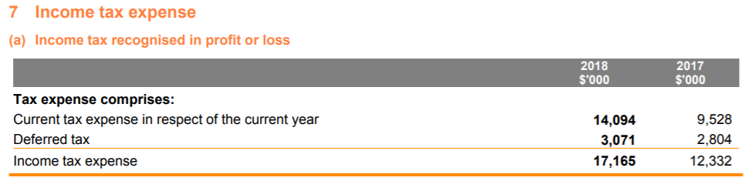  As you can see your company has a tax expense meaning they owe money to the taxation office. I also included the notes that breakdown the tax expense of your company. I hope this is helpful and can help you complete your income statement. The only other issues with this statement is formatting as mentioned in your previous statements. You have again used the $ which I suggest you remove as well as the use of decimals. Some of your figures have two decimal places while others have none. I suggest you fix this error and make it consistent throughout your statements.  I also noticed that you have not yet included a word document. I suggest you do this to indicate the errors you struggled with and how you resolved them as well as any other communication you had with peers during this stage.  If you manage to complete your income statement and your word document before the due date I will be happy to have a look over them for you to further provide you with feedback.
Step 4  Individual feedback with other students. | This section is not available
Overall ASS#2 Steps 3 & 4 | Overall, I enjoyed reading through your financial statements and I hope that the feedback I have provided is useful. I think you are generally on the right track and just have a few tweaks you need to make. If you have an questions or would like me to look over any other areas that you have since completed feel free to contact me at zoe.l.jeffery@cqumail.com. I hope this has been helpful and good luck with the remainder of this assessment

Conclusion
Overall, steps 3 and 4 were challenging but definitely a learning experience. Although the assignment didn’t go exactly as I had planned, I still learnt a lot and can really see how this relates to the outside world. One of the biggest things it taught me if I’m being honest, is time management. However, learning how to restate accounts is very interesting and very easy if you know what your doing. It was a big learning curve in all aspects, but I am very grateful I have the support of my peers and lectures which will help me succeed.

