Assignment Stage 1: Steps 2-5
Aimee Seri
STEP 2: Blog Link and Moodle Profile
Personal Blog Link: Aimee's Blog
Moodle Blog Link: My Moodle Page

STEP 3: Introduction to My Company
At the beginning of week 1 i was quite eager to delve straight into this subject and discover the learning potential it has. I’d be lying if I said I was an organised person and had read through the unit profile or even started to critically think about what may lie ahead, so when I found out that our first assessment involved receiving a company, I felt nervous as I was unsure what I’d have to do with this information. As I skimmed through and looked at the companies that had been assigned to the rest of the class, I became quite intrigued as I recognised a lot of companies and took interest. However, when I found my company, I had no idea who they were or what they did. I instantly started to research them, and I quickly discovered what their sort of business they partake in. With all that being said, I should introduce my company to everyone, Service Stream.
Background Information
Service Stream Pty Ltd
They are essentially a profitable and dynamic business that keep individuals and businesses connected to vital services Australia Wide. They specialise in mobile communications, fixed communications, electricity, water as well as gas and are leading providers in all these areas. They take pride in their design, construction and maintenance services that are vigorously used to sustain Australia’s infrastructure. When I explored even further into their business, I came to the realisation that they are at the forefront of their field and are continuing to excel and succeed at a rapid rate. This allows their horizons to broaden as more innovation is being invested in which aids Service Stream to continue to grow and build an even better reputation. I also found whilst researching that service stream have 14 subsidiaries companies that are all related which can be viewed by observed by moving your attention below.
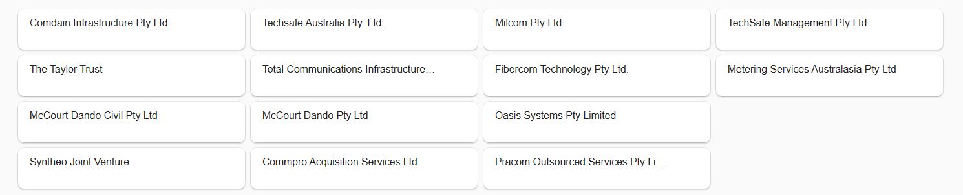

With over 1800 employees, Service Stream work on behalf of Australia’s most trusted brands to offer their clients with certainty through their experience, strong safety record and commitments to producing the finest customer service. They do this by following five key steps which include access, design, build, install and service which allows them to be the best company they can be.
In a December 2018 Financial Review article Service Stream have seemed to hit the jackpot as that strike a $160 million deal. The article reads about how the telecommunications service provider got lucky to score an acquisition of an Australian infrastructure business relating to gas and water services. It’s expected to increase their revenues annually which complies the company’s strategic plan. The Comdain Infrastructure is the company Service Stream have signed this deal with. This company is prestigious in the infrastructure field and are understood to have a $20 million to $25 million annual earning which is immensely beneficial for Service Stream which also allows them to expand and grow financially.
Annual Report
When looking at the Service Stream Financial reports, it was no surprise that I basically no idea what was going on. I particularly started to analyse through the 2016 and 2018 reports as they both displayed the previous year’s financials along with the current year. At the beginning, it felt like I was reading another language, there were so many figures, graphs and tables displayed throughout the reports that I just didn’t understand. However, once I sat and critically read through the reports and highlighted all the necessary information, I felt at ease.
The very first thing I noticed when examining the reports is that Service Stream were a very successful business. Their financial position was either growing, slightly decreasing or remaining the same from year to year which I found very pleasing when reading these reports. In 2016, significant improvements were noted especially in the areas of net cash and revenue. Service Stream’s net cash was seen to immensely increase by $26.3 million bringing their total net cash to $41.1 million which I found it to be quite impressive. On the other hand, the businesses revenue increased from 2015 to 2016 by a staggering $27.7 million with all areas of their business increasing as well. It was found that their revenue has improved by $12.1 million while mobile communications was up $12.6 million, and energy and water has increased as well by $4.7 million. These increases were all due to a remarkable surge of customers who required certain connections to be performed, particularly around fixed communications as during these years NBN became renowned and more and more individuals and businesses desired it. Another thing I found interesting was that the businesses current assets had exceeded their current liabilities by $67 million which is a massive advantage. Having said that though, the overall financial position of Service Stream surprisingly slightly declined as their net assets had reduced by $185.4 million which is relatively high figure. I found this decline very interesting as the business produced a record Net Profit After Tax (NPAT) of $20 million but when investigating further, I came to the realisation that the decline had still occurred due to decrease is net assets. However, overall the business is still immensely solid and were standing strong as at the 30th June 2016 even though there was a slight decline from the previous year. Below I have placed a table that was displayed in Service Stream’s 2016 annual report which really assisted me in understanding everything that was going on throughout the report.

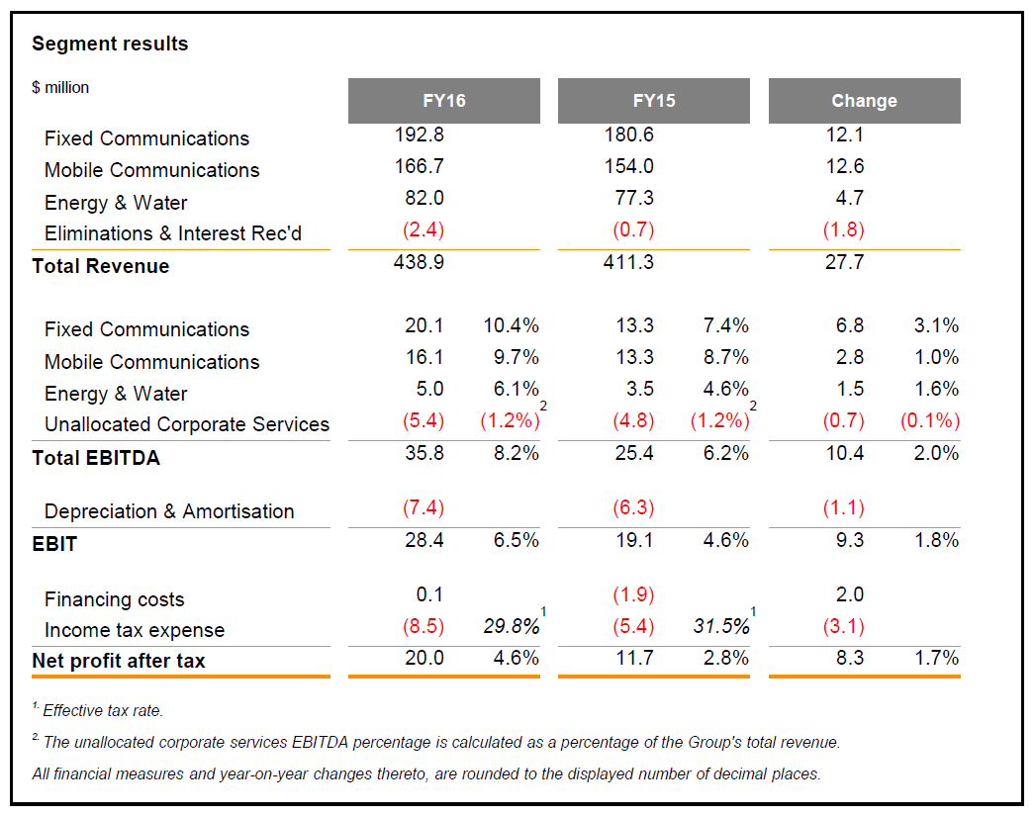

Furthermore, when analysing the 2017 and 2018 Annual Reports, business growth was set in motion and it was evident that was excelling in their field during these years. Once again net cash and revenue were at the forefront of the businesses success as they had continued to increase. As a collective, the group’s revenue had improved $130.7 million from the previous year. It was clear that the growth of fixed communications (+40%), network connections (+19%) and energy and water (+11%) were still on an up. The group concluded their financial year with $73.0 million net cash which was another increase. Overall the financial position of Service Stream grew in 2017 and remained relatively the same in 2018 with net assets reaching $206.9 million. Once again, their current assets exceeded their current liabilities meaning the company is still durable and remain to be at the best in the business.
I do have one underlying question that have arisen after reading through all four annual reports as not everything was completely clear to me. For example, in 2016 when the business was on a slight decrease, why was it that their net assets impacted their whole financial position when everything else such as revenue, net cash as well as assets and liabilities were textbook? Other than that, I understood the rest of the financial reports and came to a few realisations on how successful this company is as well as learning some new terminology surrounding annual reports and businesses such as service stream. Below I have provided you with the links to both the 2016 and 2018 annual reports.
http://www.servicestream.com.au/uploads/other/ed3438bea9e3506701383735c5076ddbbf0f644f.pdf
http://www.servicestream.com.au/uploads/other/93f5b04382a2fed9e244636a2539e0486bef189f.pdf

Studiosity:
Top Three Blogs:
Step 4: Company Spreadsheet
View Attached Excel Spreadsheet
Step 5: KCQ’s
Chapter 2
I feel as though it was only yesterday that I wrote my first KCQ, yet here I am once again writing another one (well two). This time around is different though, if any of you read my first KCQ (on my blog) it was easy to see that I was very nervous and had no clue what to expect out of not only the KCQ but the entire subject. However, it’s nearly week 4 now and I have a whole new outlook on everything therefore I can get so much more out of this class. When I started to read Chapter 2, I was immediately intrigued by the very first quote spoken by the prestigious Albert Einstein “You have to learn the rules of the game. And then you have to play better than anyone else” I was astounded at how much volume this quote spoke to me. I have to say this was the best way to start a 12-page chapter. As I read through it was evident that the purpose or main concept of this chapter was teaching us how to play the game as well as explain the rules that go along with succeeding in this game, we call accounting. I never actually knew how many outsiders were interested in understanding the realities of a firm, I thought it just stopped at the manager. It was also made clear in the first few chapters that we were going to be learning about the regulations surrounding the financial information set to be given out, as well as allowing us to get insight into the similarities of firms across the world while also looking the differences they impose too.

I must say, I did not realise or take much notice of the quotes that were written at the top of each section when reading the introduction and chapter 1. However, the quotes are the one of the few things keeping me interested and wanting to read more, they are very quirky and have allowed me to engage in these readings a lot better. I was quite shocked to learn about how many rules and regulations there are surrounding this topic and it made me think why there had to be so many in the first place? And wonder what would happen if these rules weren’t followed? As I read through the information in relation to the access banks have, I found myself already knowing as I do work in an accountant firm and understand why banks needs this information. I did, however, enjoy reading the background information provided about the growing regulations and where it all these rules stemmed from. As I kept reading, I was interested to read about the GAAP because I had seen it so much in all the peerwise questions and wondered who they are and what they do. I was surprised to learn that they are literally the rules of the game that are followed by accountants, not only nationally but internationally as well with the exception that they may vary from country to country. It was also quite interesting to see the relation between the GAAP, AASB and ASX as I knew a fair bit about the AASB and ASX but had only heard about GAAP whilst being in this subject. Once again, this knowledge comes from working in the industry.

I didn’t have any issues reading through ‘You can’t have a rule for everything’ as it made sense. If there was a rule for everything, life would not be fun, nor would it be productive if I’m being honest. It just makes for more rules that won’t be followed and it is just not viable. I also had a good understanding of accrual accounting and found that to be an easy read. However, the definitions and examples of accrual accounting did allow me to build a greater knowledge of the term.

Lastly, I found the ‘Quality of Information’ section probably the hardest to wrap my head around as I just couldn’t really understand what I was reading. Maybe it was because I’ve been nearly done this whole assessment in one day and my brain is just on information overload. But as I slowly read through it and allowed myself to grasp the concept, I found myself learning more and more. I saw how financial statements can differ from one another and how key qualities such as relevance and faithfulness are vital when dealing with financial information. I now know how all this information is related to the main concepts of this chapter and how they work collectively together.

Chapter 3

Aforementioned, I have done these KCQ’s in one day which may seem like nothing but it’s a lot of information for my brain to process therefore when I came to read chapter 3, it was safe to say I was tired. But I pushed through and feel as though I have a better understanding of all these new concepts.
It was evident after reading the first sentence that this chapter was going to introduce the use of financial statements and the analogy Martin used perfectly sums it up. It is like meeting someone at a party for the first time and I was 100% nervous and overwhelmed when it came to reflecting on this chapter. I had a good idea about what a financial statement looks like and what is involved, but I really only knew in depth information about a balance sheet, everything else I had heard of before but never really knew what information they held. As I read through the information on the balance sheet I felt at ease as I knew the terminology and understood that it shows the position of a business at a certain day. I look at balance sheets daily whilst working so I had no issues with that.
However, when it came to reading about incomes statements, statements of changes in equity and cash flow statement I was lost. With that being said, I decided to write down the definitions for each one as well as some background information and examples of a piece of paper and occasionally read it so it could become second nature to me. Therefore, this is what I discovered. An income statement is used to indicate a company’s financial position over a period of time which usually their financial year. Both the balance sheet and statement of cash flow are vital for an income statement. I also learnt that this statement can be known as a profit and loss statement which coincidentally is what my company had in their annual report which made me slightly confused. This made me wonder, why are there two different names for the same thing? And why do some businesses use income statement while others use profit and loss?

Due to the statement of cash flows being so key to an income statement, it was only fair I learn that one next. This one was quite easy to remember as cash flow is sort of self-explanatory. It summarises the cash going in and out of a business over a particular accounting period, it allows individuals to see how well the business is going and their overall cash position. While a statement of changes in equity analyses the company’s equity from the start of their accounting period to the end. It mainly focuses on the business’s profits and dividend payments. Once I learnt and memorised all that information, I realised how important these financials statements are for a company and how they can track and improve their overall financial position by just looking at these statements. One thing I was very surprised about though, are how many accounting equations there are and how much they are relied upon. I found them and the tables used throughout the chapter very helpful and allowed me to grasp a better understanding.
To sum up my reflection on chapter 3, I found that I learnt a lot in regard to accounting by simply just reading critically analysing the information given to me. I came out with a better understanding of accounting itself, and why businesses utilise everything it has to offer as it is such a vital part of being successful and growing.
Step 6: Feedback

